XIV INTERNATIONAL FORUM OF FINANCE AND BANKING (MFFB)  MODERN FINANCE AND THE ECONOMIC THOUGHT TOWARDS THE CHALLENGE OF BALANCE  IN THE MARKET ECONOMY | Warsaw University of Life Sciences - SGGW  Department of Finance  Nowoursynowska str. 166  02-787 Warsaw  Phone: (+48 22) 59 342 50  Fax (+48 22) 59 342 37  e-mail: mffb@sggw.edu.pl
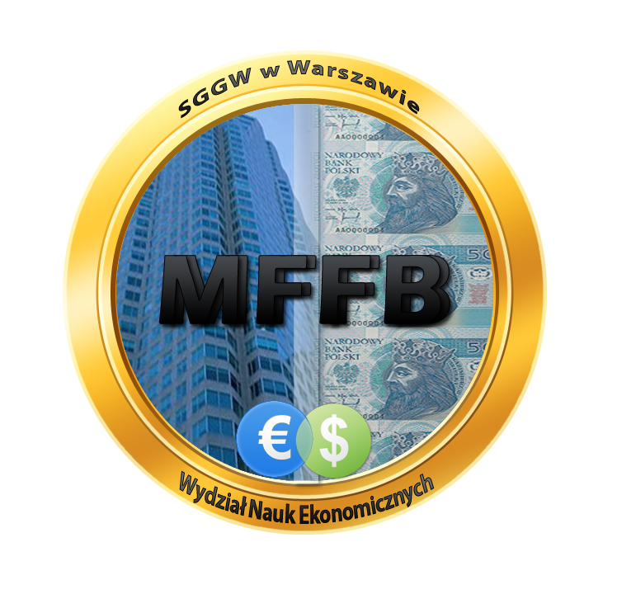

APPLICATION FORM
Please send to the e-mail: mffb@sggw.edu.pl
or register through the website http://mffb.ieif.sggw.pl/ till 31.10.2022

Name and Surname (title/scientific or professional degree):
...…………………………………………………………………………………………………
Name of the institution with the postal address (required for invoice issuance ∗):
…...………………………………………………………………………………………………
…………………………………………………………………………………………………...
Tax identification number: …………………………………………...…………………………
Mobile phone.……………..…………………………………………………………………….
E-mail: ………………………………………………………..…………………………………
Address for correspondence:………………………………….…………………………………
…………………………………………………………………..……………………………….
I declare participation in the Forum:
Without an article
With an article
PhD student with an article
Title of the article:
…...………………………………………………………………………………………………………………………………………………………………………………………..…….……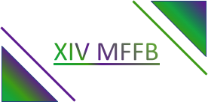 Signature .............................................................

∗ I authorize SGGW-WULS to issue an invoice without the recepient’s signature.

